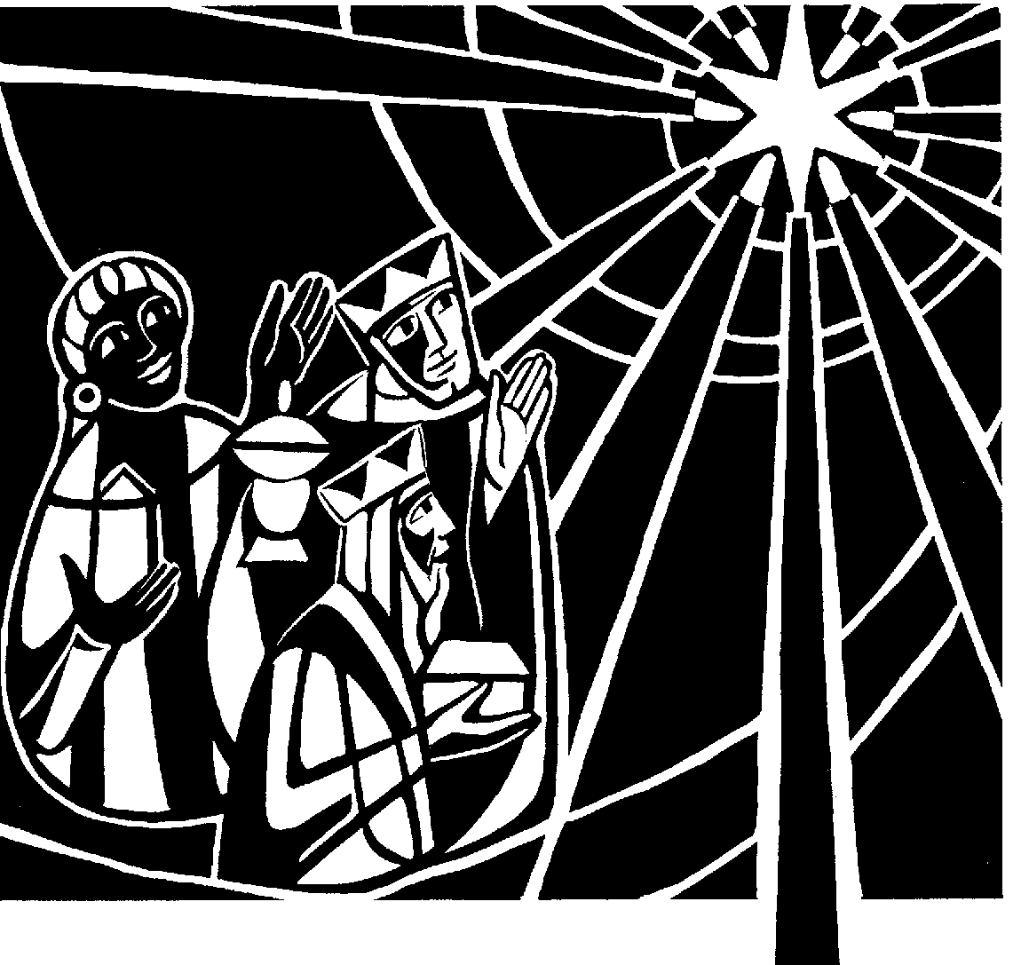

St Andrew's Church

Orford with Longford

**Epiphany**

**3rd January 2020**

**Please wear a mask. Separate households must sit apart. Only the choir can sing. Keep social distances. Keep safe. At the end of the service please leave the building and talk outside.**

*All the responses will be said.*

*We welcome the Rev Pam Lovatt as our celebrant and preacher today*

**THE GATHERING**

**Introit hymn:** **86 vv1-3, 6 ‘From the eastern mountains’**

Priest: In the name of the Father and of the Son and of the Holy Spirit. **Amen**

Priest: Blessed are you, Lord our God, King of the Universe!

All: From the rising of the sun to its setting

your name is proclaimed in all the world.

Priest: The Lord of glory be with you.

All: The Lord bless you.

All: Almighty God, to whom all hearts are open, all desires known, and from whom no secrets are hidden: cleanse the thoughts of our hearts by the inspiration of your Holy Spirit, that we may perfectly love you, and worthily magnify your holy name; through Christ our Lord. Amen.

Priest: The grace of God has dawned upon the world through our Saviour Jesus Christ, who sacrificed himself for us to purify a people as his own. Let us confess our sins.

All: Most merciful God, Father of our Lord Jesus Christ, we confess that we have sinned in thought, word and deed. We have not loved you with our whole heart. We have not loved our neighbours as ourselves. In your mercy forgive what we have been, help us to amend what we are, and direct what we shall be; that we may do justly, love mercy, and walk humbly with you, our God. Amen.

Priest: Almighty God, who forgives all who truly repent, have mercy upon you, pardon and deliver you from all your sins, confirm and strengthen you in all goodness, and keep you in life eternal; through Jesus Christ our Lord. **Amen.**

**All Glory to God in the highest, and peace to his people on earth. Lord**

**God, heavenly King, almighty God and Father, we worship you, we give you thanks, we praise you for your glory. Lord Jesus Christ, only Son of the Father, Lord God, Lamb of God, you take away the sin of the world: have mercy on us; you are seated at the right hand of the Father: receive our prayer. For you alone are the Holy One, you alone are the Lord, you alone are the Most High, Jesus Christ, with the Holy Spirit, in the glory of God the Father. Amen.**

**The Collect:** O God, who by the leading of a star manifested your only Son to the peoples of the earth: mercifully grant that we, who know you now by faith, may at last behold your glory face to face; through Jesus Christ our Lord, who is alive and reigns with you, in the unity of the Holy Spirit, one God, now and for ever. **Amen**

#### **THE LITURGY OF THE WORD**

**A reading from the book of the prophet Isaiah** *(Isa 60. 1–6)*

Arise, shine; for your light has come, and the glory of the LORD has risen upon you. For darkness shall cover the earth, and thick darkness the peoples; but the LORD will arise upon you, and his glory will appear over you. Nations shall come to your light, and kings to the brightness of your dawn. Lift up your eyes and look around; they all gather together, they come to you; your sons shall come from far away, and your daughters shall be carried on their nurses’ arms. Then you shall see and be radiant; your heart shall thrill and rejoice, because the abundance of the sea shall be brought to you, the wealth of the nations shall come to you. A multitude of camels shall cover you, the young camels of Midian and Ephah; all those from Sheba shall come. They shall bring gold and frankincense, and shall proclaim the praise of the LORD.

This is the word of the Lord. **All: Thanks be to God.**

**Gradual hymn:** **91 ‘We three kings of orient are’**

*During this carol the three wise men will be placed in the crib*

*(After the hymn please stand for the Gospel)*

##### THE GOSPEL

Priest Christ was revealed in flesh,

proclaimed among the nations and believed in throughout the world.

**All Alleluia, alleluia, alleluia.**

Hear the Gospel of our Lord Jesus Christ according to Matthew  *(Mt 2. 1–12)*

All: Glory to you, O Lord

In the time of King Herod, after Jesus was born in Bethlehem of Judea, wise men from the East came to Jerusalem, asking, ‘Where is the child who has been born king of the Jews? For we observed his star at its rising, and have come to pay him homage.’ When King Herod heard this, he was frightened, and all Jerusalem with him; and calling together all the chief priests and scribes of the people, he inquired of them where the Messiah was to be born. They told him, ‘In Bethlehem of Judea; for so it has been written by the prophet: “And you, Bethlehem, in the land of Judah, are by no means least among the rulers of Judah; for from you shall come a ruler who is to shepherd my people Israel.”’ Then Herod secretly called for the wise men and learned from them the exact time when the star had appeared. Then he sent them to Bethlehem, saying, ‘Go and search diligently for the child; and when you have found him, bring me word so that I may also go and pay him homage.’ When they had heard the king, they set out; and there, ahead of them, went the star that they had seen at its rising, until it stopped over the place where the child was. When they saw that the star had stopped, they were overwhelmed with joy. On entering the house, they saw the child with Mary his mother; and they knelt down and paid him homage. Then, opening their treasure-chests, they offered him gifts of gold, frankincense, and myrrh. And having been warned in a dream not to return to Herod, they left for their own country by another road.

This is the Gospel of the Lord

**All: Praise to you, O Christ**

The Sermon *(please sit)*

Priest: We believe in one God, **the Father, the almighty, maker of heaven and earth, of all that is, seen and unseen.**

We believe in one Lord, Jesus Christ, the only Son of God, eternally begotten of the Father, God from God, Light from Light, true God from true God, begotten, not made, of one Being with the Father; through him all things were made. For us and for our salvation he came down from heaven, was incarnate from the Holy Spirit and the Virgin Mary and was made man. For our sake he was crucified under Pontius Pilate; he suffered death and was buried.

On the third day he rose again in accordance with the Scriptures; he ascended into heaven and is seated at the right hand of the Father. He will come again in glory to judge the living and the dead, and his kingdom will have no end.

We believe in the Holy Spirit, the Lord, the giver of life, who proceeds from the Father and the Son, who with the Father and the Son is worshipped and glorified, who has spoken through the prophets. We believe in one holy catholic and apostolic Church. We acknowledge one baptism for the forgiveness of sins. We look for the resurrection of the dead, and the life of the world to come. Amen.

Priest: Today the Wise Men knelt before our Saviour. Let us also kneel to worship him with great joy, and to make our prayer to his heavenly Father.

*Each section ends:* Lord, in your mercy. **All: Hear our prayer.**

**Please remember in your prayers:**

* **those who are ill: :** Marion Greatorex, Pauline Smith, Michelle Smith, Michael Stringer, Joyce Crozier, Pete Harris, Eileen Whitehead, Lynn Shaw,

Bob Birbeck, Carl Howard.

* **those who have died:** David Sutcliffe
* **those whose year's mind falls at this time**:

***Sunday:*** Reg Griffiths

***Monday:*** Roy Gardner, Ron Hollingsworth

***Wednesday:*** Betty Hilton

***Thursday:*** May Blackmore, Joan Greatorex, Ivan Holloway

***Friday:*** Ernest Best

After the final petition:

Leader: Merciful Father, **accept these prayers for the sake of your Son,**

**our Saviour Jesus Christ. Amen.**

THE LITURGY OF THE SACRAMENT

**The Peace**   *(please stand)*

Priest Our Saviour Christ is the Prince of Peace. Of the increase of his govern-ment and of peace there shall be no end.

The peace of the Lord be always with you.

All And also with you

Priest: Let us offer one another a sign of peace.

*Everyone is invited to share the peace with one another by waving or bowing or both*

Eucharistic Prayer E *(please kneel)*

Priest:The Lord is here.

**All His Spirit is with us.**

Priest:Lift up your hearts.

**All We lift them to the Lord.**

Priest:Let us give thanks to the Lord our God.

All It is right to give thanks and praise.

Priest:All honour and praise be yours always and everywhere, mighty creator, ever-living God, through Jesus Christ your only Son our Lord: for at this time we celebrate your glory made present in our midst. In the coming of the Magi the King of all the world was revealed to the nations. In the waters of baptism Jesus was revealed as the Christ, the Saviour sent to redeem us. In the water made wine the new creation was revealed at the wedding feast. Poverty was turned to riches, sorrow into joy. Therefore with all the angels of heaven we lift our voices to proclaim the glory of your name and say our joyful hymn of praise:

All: Holy, holy, holy Lord, God of power and might, heaven and earth are

full of your glory. Hosanna in the highest. Blessed is he who comes in the name of the Lord. Hosanna in the highest.

Priest:We praise and bless you, loving Father, through Jesus Christ, our Lord;

and as we obey his command, send your Holy Spirit, that broken bread

and wine outpoured may be for us the body and blood of your dear Son.

On the night before he died he had supper with his friends and, taking bread, he praised you. He broke the bread, gave it to them and said: Take, eat; this is my body which is given for you; do this in remembrance of me.

When supper was ended he took the cup of wine. Again he praised you, gave it to them and said: Drink this, all of you; this is my blood of the new covenant, which is shed for you and for many for the forgiveness of sins. Do this, as often as you drink it, in remembrance of me.

So, Father, we remember all that Jesus did, in him we plead with confidence his sacrifice made once for all upon the cross. Bringing before you the bread of life and cup of salvation, we proclaim his death and resurrection until he comes in glory.

Great is the mystery of faith:

All Christ has died: Christ is risen: Christ will come again.

Lord of all life, help us to work together for that day when your kingdom comes and justice and mercy will be seen in all the earth. Look with favour on your people, gather us in your loving arms and bring us with all the saints to feast at your table in heaven. Through Christ, and with Christ, and in Christ, in the unity of the Holy Spirit, all honour and glory are yours, O loving Father, for ever and ever. **Amen.**

Priest: Let us pray with confidence as our Saviour taught us

All: Our Father, who art in heaven, hallowed be thy name; thy kingdom come; thy will be done; on earth as it is in heaven. Give us this day our daily bread. And forgive us our trespasses, as we forgive those who trespass against us. And lead us not into temptation; but deliver us from evil. For thine is the kingdom, the power and the glory, for ever and ever. Amen.

Priest: We break this bread to share in the Body of Christ.

**All: Though we are many, we are one body,**

**because we all share in one bread.**

All: Lamb of God, you take away the sin of the world, have mercy on us.

Lamb of God, you take away the sin of the world, have mercy on us.

Lamb of God, you take away the sin of the world, grant us peace.

Priest: We break the bread of life, and that life is the light of the world.

All: God here among us, light in the midst of us, bring us to light and life.

Holy Communion is administered at the front of Church. Everyone is warmly invited to receive Holy Communion at this Eucharist. Go up to the altar steps. Return by either side and not down the middle .Keep your mask on and remove to eat on the way back.

*During the distribution of the Sacrament, the following is sung:*

**74 ‘What child is this?’**

**After Communion:**

Priest: Let us pray: Lord God, the bright splendour whom the nations seek: may we who with the wise men have been drawn by your light discern the glory of your presence in your Son, the Word made flesh, Jesus Christ our Lord. **Amen**

All: Almighty God, we thank you for feeding us with the body and blood of your Son, Jesus Christ. Through him we offer you our souls and bodies to be a living sacrifice. Send us out in the power of your Spirit to live and work to your praise and glory. Amen.

Priest: Christ the Son of God perfect in you the image of his glory and gladden your hearts with the good news of his kingdom; and the blessing of God almighty, the Father, the Son and the Holy Spirit, be among you and remain with you always. **Amen**

**Recessional hymn:** **84 ‘Brightest and best of the sons of the morning’**

Priest: Go in joy and peace to love and serve the Lord.

All: In the name of Christ. Amen

✠ ✠ ✠ ✠ ✠ ✠ ✠ ✠ ✠ ✠ ✠ ✠ ✠ ✠ ✠ ✠ ✠ ✠ ✠ ✠ ✠ ✠ ✠ ✠ ✠ ✠ ✠ ✠ ✠ ✠ ✠ ✠ ✠ ✠ ✠

**Services and Notices for the week:**

**Next Sunday The Baptism Of Christ**

**(10th Jan) 10.00am**

We are pleased to announce that the Revd Gill Hitchen has been appointed

Priest-in-charge at St. Andrew’s for a period of 2 years. She has been a

curate in the Parr team at St. Helens and trained for the ministry at

Wycliffe Hall. Before ordination she worked as a community project

manager for churches in Kirkby, as a restaurant manager and as a

powerboat instructor! Her job will be to engage a wide variety of people in

a vision for growth and discipleship and work with the wider deanery to

discern the next steps for the future of St. Andrew’s. We look forward to

her starting her ministry. The date for her licensing has not been fixed yet

but it is expected to be some time during Lent.

For more information on our new priest see

https://liverpool.anglican.org/Meet-Revd-Gill-Hitchen

*A note on terminology*

A vicar (eg Fr Michael) has primary administrative, pastoral and liturgical

responsibilities for the parish and the post is more or less permanent.

A priest-in-charge has the responsibilities and duties of a vicar but on a

temporary basis at the discretion of the bishop. Generally priests-in-charge

are appointed when re-organisation is in the offing.

**Epiphany 3rd January 2020**

Priest: On this great day, the Wise Men knelt before our Saviour. Let us also kneel to worship him with great joy, and to make our prayer to his heavenly Father.

(All kneel)

Leader: Father, the Wise Men came from the east to worship your Son:

grant to Christians everywhere a true spirit of adoration.

Leader: Lord, in your mercy

**All: Hear our prayer.**

Leader: Father, you are the King of kings and Lord of lords:

grant an abundance of peace to your world.

Hear our prayers for the people of the world caught up in the pandemic and especially for those in the third world who will probably have to wait before vaccinations come their way.

Leader: Lord, in your mercy

**All: Hear our prayer.**

Leader: Father, the Holy Family shared the life of the people of Nazareth:

protect in your mercy our neighbours and our families.

Hear our prayers for the world-wide family,

and especially for those caught up in disaster and violence at this time. In particular we pray for those caught up in the earthquake in Croatia.

Leader: Lord, in your mercy

**All: Hear our prayer.**

Leader: Father, though you were rich, for our sake you became poor:

show your love for the poor and powerless,and strengthen the sick, including Marion Greatorex, Pauline Smith, Michelle Smith, Michael Stringer, Joyce Crozier, Pete Harris, Eileen Whitehead, Lynn Shaw,

Bob Birbeck, Carl Howard and all who suffer.

Leader: Lord, in your mercy

**All: Hear our prayer.**

Leader: Father, the Wise Men presented to your Son gold, frankincense and myrrh:

accept the gifts we bring, and the offering of our hearts at the beginning of this new year.

Leader: Lord, in your mercy

**All: Hear our prayer.**

Leader: Father, you are the King of heaven, the hope of all who trust in you:

give the wonders of your salvation to those who have died recently including Dave Sutcliffe and Eileen Whitehead and to all the people whose year’s mind falls at this time including Reg Griffiths, Roy Gardner, Ron Hollingsworth, Betty Hilton, May Blackmore, Joan Greatorex, Ivan Holloway and Ernest Best.

Leader: Lord, in your mercy

**All: Hear our prayer.**

Leader: Rejoicing in the fellowship of wise men, shepherds, and angels,

and of the Blessed Virgin Mary and Saint Joseph,

we commend ourselves and all people to your unfailing love.

Merciful Father,

**All: accept these prayers,**

**for the sake of your Son,**

**our Saviour Jesus Christ. Amen.**

**Epiphany 3rd January 2020**

**A reading from the book of the prophet Isaiah**

Arise, shine; for your light has come, and the glory of the LORD has risen upon you. For darkness shall cover the earth, and thick darkness the peoples; but the LORD will arise upon you, and his glory will appear over you. Nations shall come to your light, and kings to the brightness of your dawn. Lift up your eyes and look around; they all gather together, they come to you; your sons shall come from far away, and your daughters shall be carried on their nurses’ arms. Then you shall see and be radiant; your heart shall thrill and rejoice, because the abundance of the sea shall be brought to you, the wealth of the nations shall come to you. A multitude of camels shall cover you, the young camels of Midian and Ephah; all those from Sheba shall come. They shall bring gold and frankincense, and shall proclaim the praise of the LORD.

This is the word of the Lord.

**Thanks be to God.**